COVID-19 Mortality Excess and Cost-Effective Analysis of Different Treatments

**Introduction**

COVID-19 pandemic has created a public health crisis with serious consequences in most countries worldwide, and Mexico has been one of the most affected. On January 14, 2020, the Mexican government reported 1,019,543 accumulated cases of Covid-19 and 100,104 deaths 1. This makes it the eleventh country in the world in the number of confirmed cases and the fourth in reported deaths.2 The current situation has created the urgency to study mortality associated to Covid-19 Usually, studies focus in factors often associated with critical illness and fatal outcome such as age, sex or certain comorbidities 3,4 and calculate mortality estimates of a cohort of patients with COVID-19, however people who are part of the cohorts of these studies have an expected mortality rate for other causes associated with its particular characteristics (such as sex or age) and a certain number of fatal outcomes were expected. The remaining mortality in that same period of time could be called excess mortality due to Covid-19.

Excess mortality [pending explanation] from a disease can be a very useful measure for decision makers, since it allows to evaluate different strategies that attempt to modify and mitigate directly this specific risk in the population. Currently, there are neither studies that have estimated the excess mortality from Covid-19, nor that attempt to evaluate the effectiveness of various strategies to reduce mortality from Covid-19. The estimation of this excess mortality for the Mexican population provides an opportunity to evaluate possible strategies to reduce the mortality of Covid-19 even if they have not yet been applied in the country.

The aim of this analysis is twofold. First, to estimate the Covid-19 specific mortality for the population over 45 years of age in Mexico using relative survival methods. Second, to quantify the costs, effectiveness and cost-effectiveness using a microsimulation model of two different treatments that aim to reduce the Covid-19-specific mortality: Dexamethasone and Remdesivir. All calculations, models and graphs were done using R,5 and Rstudio software.6

**Methods**

*Overview*

*Data*

I used information from the National Epidemiological Surveillance System base for monitoring possible cases of Covid-19. This dataset includes people tested for SARS-CoV-2 in Mexico and contains only data obtained from studies done on suspicious persons when detected in the medical units of the health sector7 and it is daily updated. The last update date of the analyzed data is January 14th, 2020. Database is filtered to select only people with a positive test result to SARS-CoV-2, older than 44 years and that have been hospitalized. Individuals in the database are classified by sex, age group and if the patient required intubation. There are 4 age groups: “45 - 54”, “55 - 64”, “65 - 69”, “70 +” years old. To classify if the patient had a fatal outcome or not it was assumed that every individual that is not registered with an actual date of death is alive.

Background mortality rates for Mexican population in 2020 come from the National Population Council demographic indicators.8 Data bases includes mortality projections until 2050 which were modified to produced time series of mortal cases by sex and age at the national, state and county level. Daily mortality rates by sex and age for 2020 at a national level were used for the models in this work.

*Relative Survival*

Relative survival and excess mortality analysis is a methodology that deals with registries of a cohort diagnosed with a disease and follow up its time and vital status, though causes of death are unknown or not clear.9 This methodology is usually used in cancer studies,9,10 but it has been used in other diseases in national analysis such as HIV11 or in cohort of people infected with Hepatitis.12

Relative survival, crude probability of death and net survival are often reported in relative survival analysis.9 The first one consists in the ratio between the survival of the cohort analyzed and the expected survival of the population normally obtained from population mortality information. Relative survival is defined as 9,13 This methodology allows to report overall hazard over time, which could be written as the sum of the disease-specific hazard and the hazard of the population 9. Disease specific hazard or “excess-hazard” is an estimate of great importance since from its calculation the disease specific and background cumulative probabilities of death can be obtained.9

Package *reslsurv*14 for R software contains the function *cmp.rel,* which allows computing cause-specific and background probabilities of death as long as is provided with data from a cohort and background mortality rates. I estimate Covid-19-specific and background probabilities of death for 60 days using the Mexican population positive for Covid-19 as a cohort and the expected mortality as the daily death rates projected for 2020.

Package *reslsurv*14 for R software contains the function *cmp.rel,* which allows computing cause-specific and background probabilities of death as long as is provided with data from a cohort and background mortality rates. I estimate Covid-19-specific and background probabilities of death for 60 days using the Mexican population positive for Covid-19 as a cohort and the expected mortality as the daily death rates projected for 2020.

Derivation of Covid-19 specific and background population hazards were obtained using the following equation:

15

where is the derivative of the cumulative probability of death, in this case .

.

Overall Hazard is the sum of previous hazards.

*Decision Model*

Previous outputs are sufficient for implement a microsimulation model. The purpose of this model is to simulate the trajectory of individuals infected with covid-19 in Mexico for 60 days and incorporate the effects of two treatments that have shown promising evidence in reducing mortality in people with Covid-1916,17: Dexamethasone and Remdesivir.

The microsimulation model utilized in this analysis is an adaptation of the state-transition microsimulation algorithm proposed for modeling for health decision sciences18 and is implemented in R. Implementation requires a model of the life cycle of a sick individual. This life cycle should be divided into mutually exclusive and collectively exhaustive states. For cases, I propose three states: Sick of Covid-19, the initial state for all the individuals in the cohort, death from Covid-19 and death from other causes.

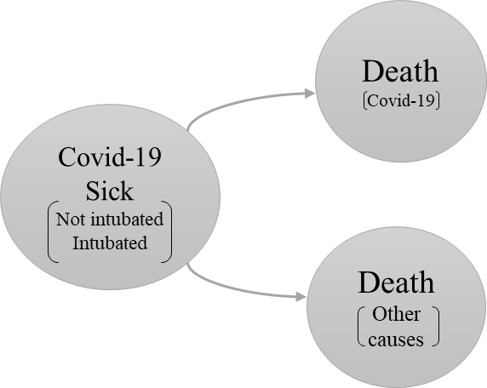

Both transition probabilities to death states are conditional on dying. To transition to death from Covid-19 is the conditional probability of having died from covid-19 given that you have died, similar for dead by other causes.

The probability that death was from covid-19 is the ratio of covid-19 specific hazard and overall hazard, while probability for other causes is the ratio between background and overall hazard, .

where the total probability of dead

Microsimulation algorithm allows the calculation of several outcomes at individual level and for the entire cohort18 such as costs and benefits of different strategies. For this is needed the individual costs and utilities for each cycle, in this case days. The following parameters are the necessary elements to implement three models of simulation models for each strategy: Do not apply treatment, treat with dexamethasone or treat with remdesivir. The description of how they were obtained is found in appendix A of this work.

|  |  |
| --- | --- |
| **Table 1: Parameter microsimulation model** | |
| **Parameters** | **Value** |
| *Number of individuals* | 481,353 |
| *Time horizon* | 60 days |
| *Number of states* | 3 |
| *Name of states* | Cov-19 + |
| Cov-19 Dead |
| Dead Other causes |
| *Annual discount rate for costs* | 0.0165 |
| *Annual discount rate for efectiveness* | 0.0165 |
| **Daily healthcare costs** | |
| *Ambulatory Covid 19 patient* | $14,500.00 |
| *Hospitalized Covid-19 patient* | $58,750.00 |
| *Average national Covid-19 patient* | $30,780.00 |
| *Dead patient* | $0.00 |
| **Daily utility weights** | |
| *Mean QALD (Qality Adjusted Life Days) loss* | 2.5 |
| *Covid-19 patient* | 0.975 |
| *Dead patient* | 0 |
| **Intervention daily costs** | |
| *Dexamethasone* | $4.40 |
| *Remdesivir* | $1,040.00 |
| **Intervention Effect** | |
| *Risk reduction of COVID-19 mortality with Dexamethasone* | 3.52% |
| *Risk reduction of COVID-19 mortality with Remdesivir* | 28.04% |
| **Daily transition probabilities** | |
| *dt_p_CoV* | Database; age, sex and day dependent |
| *dt_p_CoV_dex* |
| *dt_p_CoV_red* |
| *All monetary amounts are expressed in Mexican pesos | |

*Cost effectiveness- analysis*

Final results are used to make a Cost-Effectiveness Analysis for three strategies. R package dampack19 is used to estimate Incremental Cost Effectiveness Ratio (ICER) and determine which one is the more cost-effective.

Pendding (Correct description of Cost-Effectiveness methodology using cheers list).

**Results**

*Table Model estimated parameters (pending).*

*Covid-19 specific hazard.*

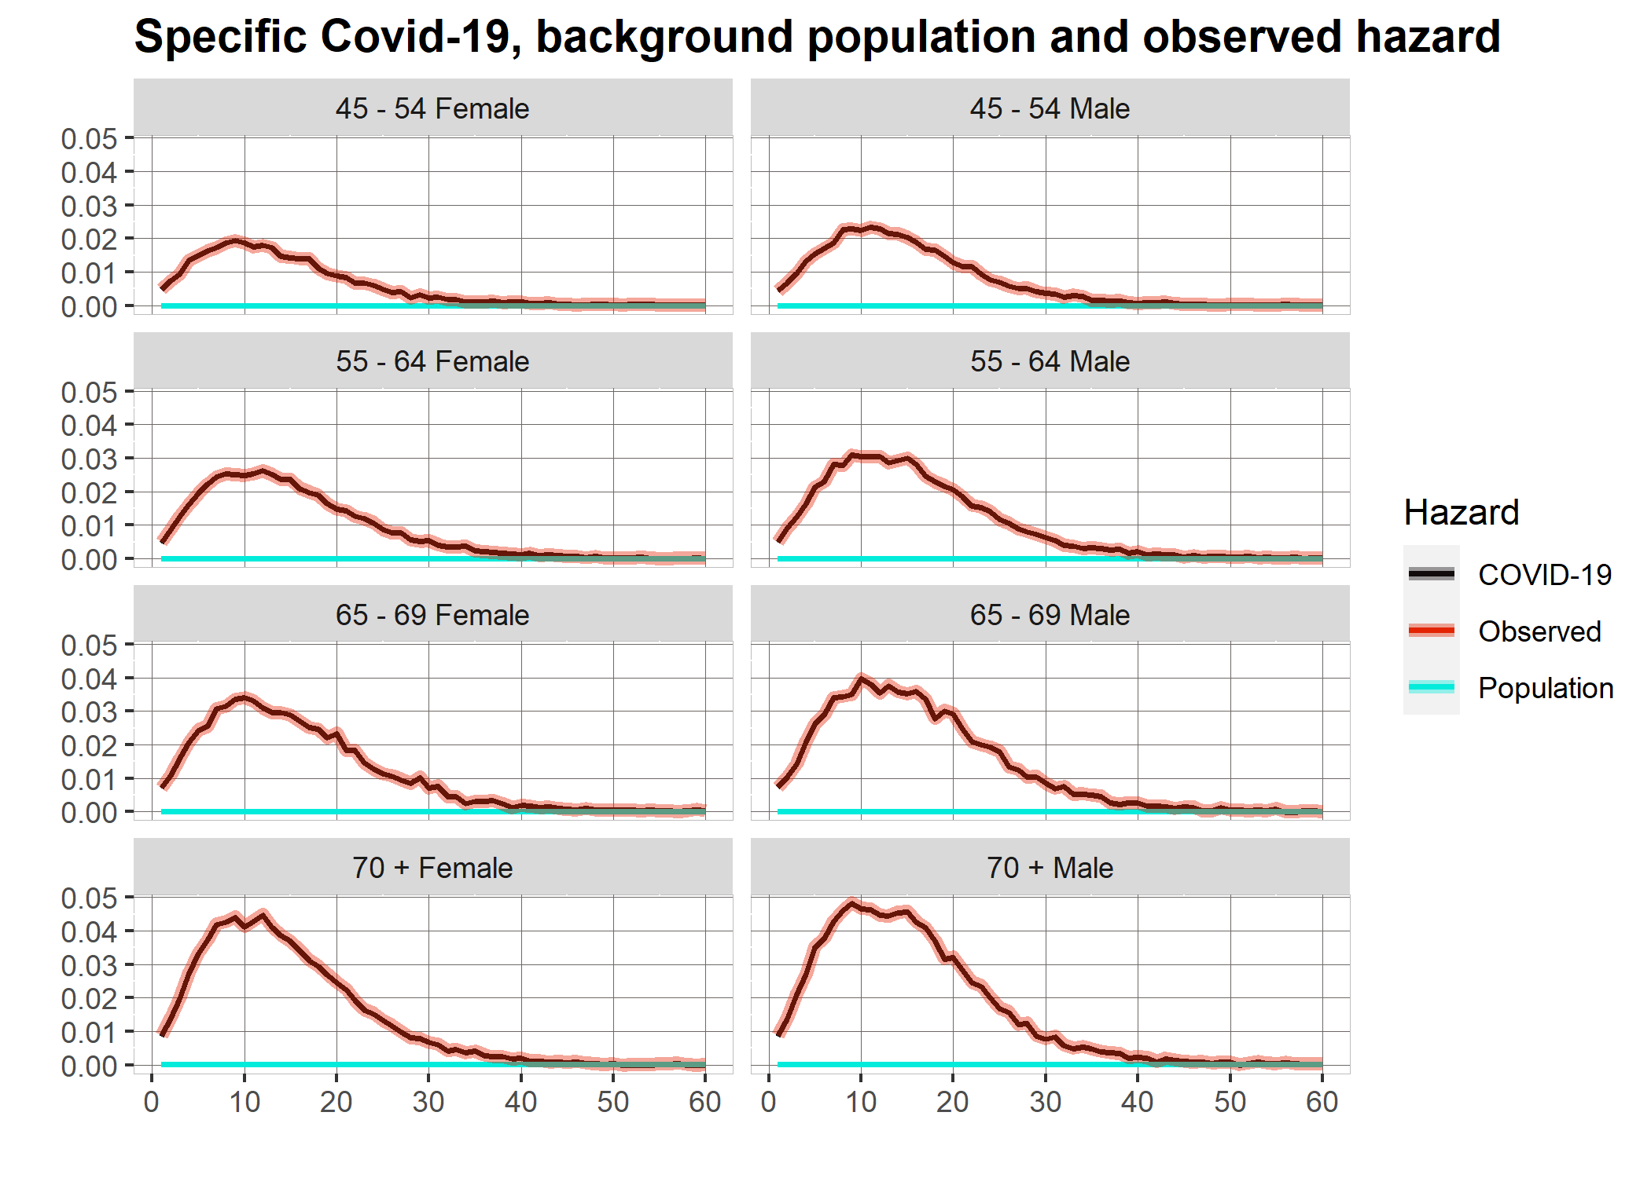

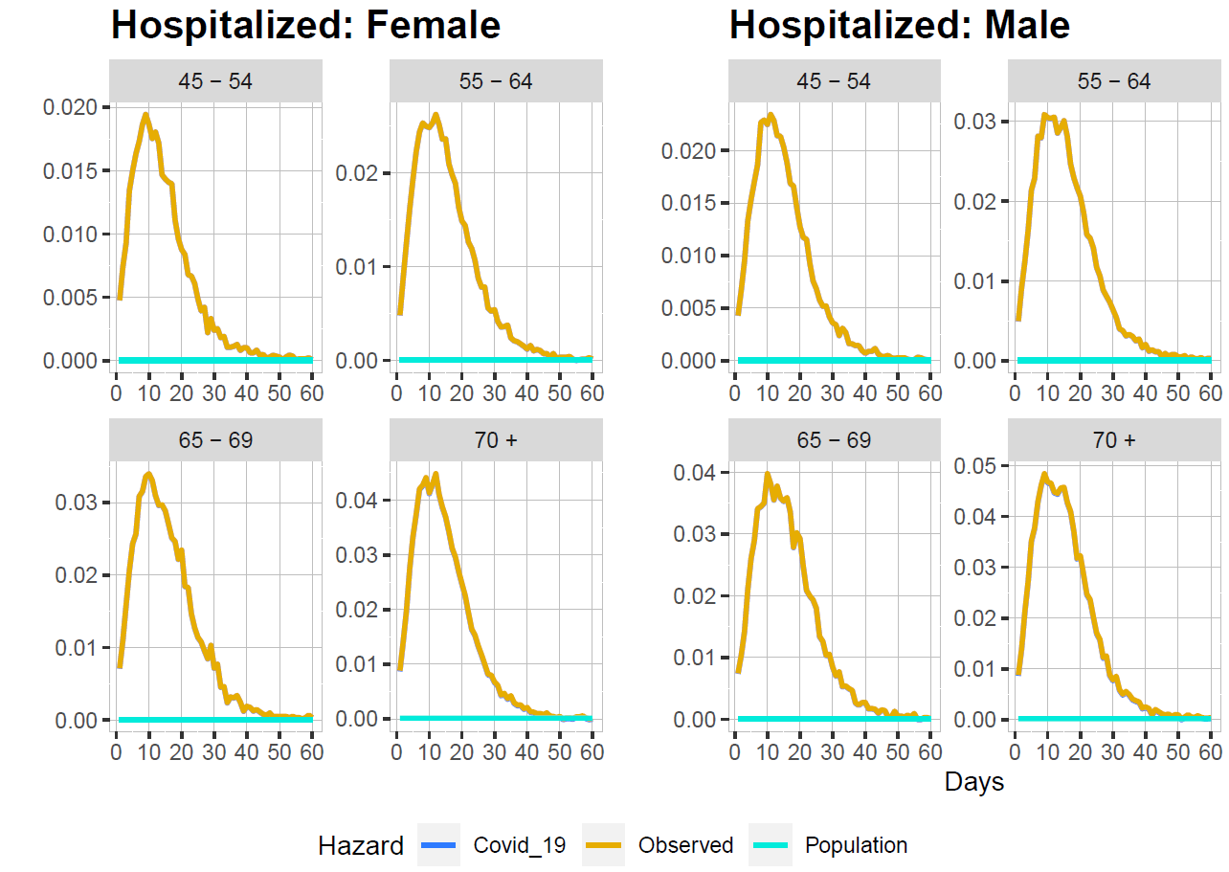

Pending (Plots of how is changed survival curves during time)

*Microsimulation models*

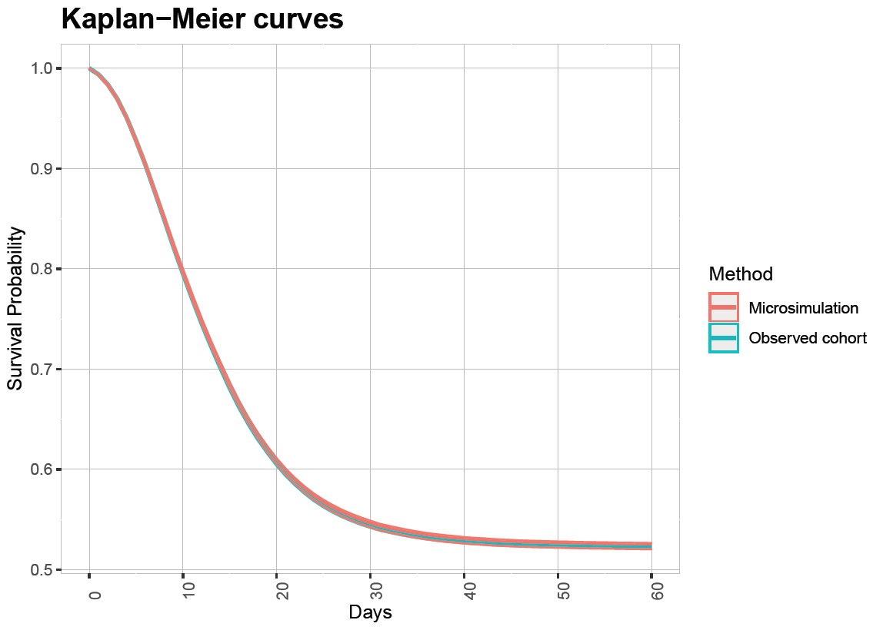

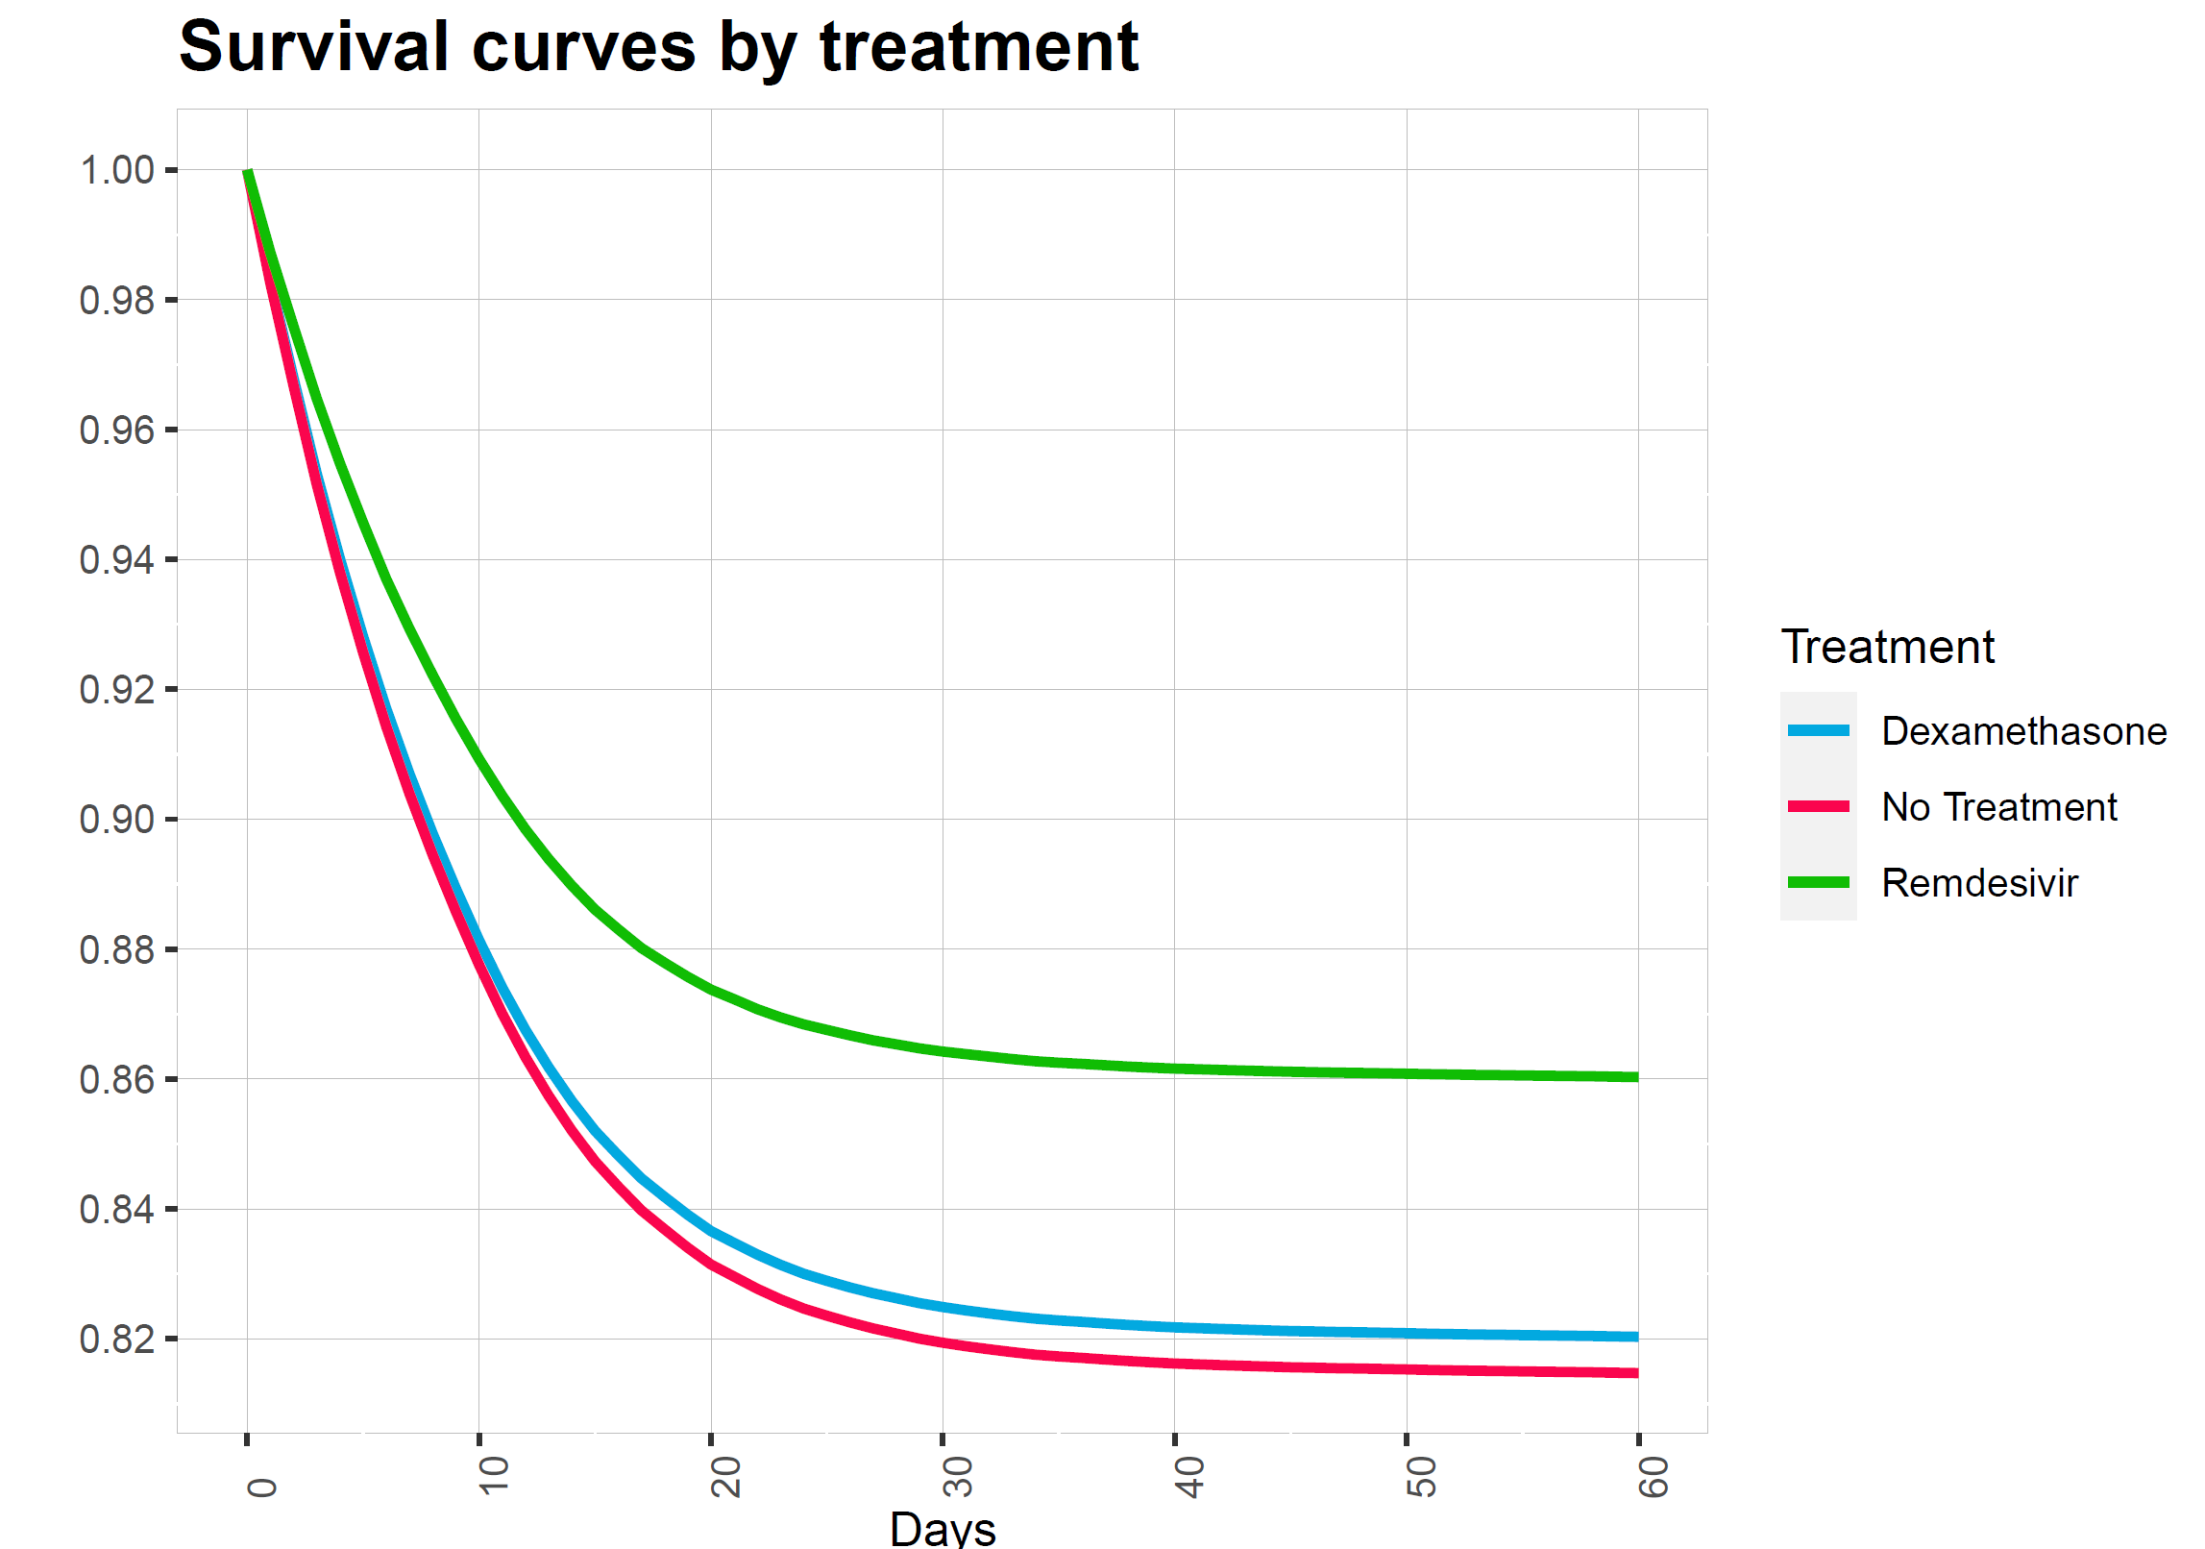

|  |  |  |  |  |  |  |  |
| --- | --- | --- | --- | --- | --- | --- | --- |
| **Table 2: Results** | | | | | | | |
| Cycle | Sick  No treatment | Sick Dexamethasone | Sick Remdesivir | Dead Cov-19 No treatment | Dead Cov-19 Dexamethasone | Dead Cov-19 Remdesivir | Dead other Causes |
| *Day 5* | 445,561 | 446,740 | 455,189 | 35,681 | 34,502 | 26,050 | 114 |
| *Day 15* | 407,865 | 410,123 | 426,518 | 73,221 | 70,962 | 54,558 | 277 |
| *Day 30* | 394,418 | 397,061 | 415,996 | 86,455 | 83,807 | 64,847 | 510 |
| *Day 60* | 392,167 | 394,856 | 414,106 | 88,341 | 85,644 | 66,335 | 912 |
| ***Total Deaths*** | | | | | | | |

*Cost-effective analysis*

|  |  |  |  |  |  |
| --- | --- | --- | --- | --- | --- |
| **Table 3: Cost Effectiveness Analysis** | | | | | |
| Strategy | Cost | Effect | Incremental Cost | Incremental Effect | ICER |
| *No Treatment* | $1,022,965.00 | - | - | - | - |
| *Dexamethasone* | $1,028,455.00 | 32.57286 | 5489.985 | 0.1692426 | 32438.56 |
| *Remdesivir* | $1,102,802.00 | 33.79081 | 74346.512 | 1.2179505 | 61042.31 |

(Pending: Table of costs, utilites and ICERS)

**Discussion**

Cumulative probabilities of death from Covid-19 (and subsequently, disease-specific hazard) are far greater than the expected death probabilities age and sex-specific for the Mexican population. Overall hazard is much greater in the first days, and then it has a constant fall until 40 days, where it takes practically the expected projected population hazard taken from the national death rates. It is worth noting that these are preliminary results presented as the project's progress and might present big changes in the final version.

A potential limit might be that the evidence of the treatments' effects is insufficient by the very nature of the phenomenon, since it has emerged this same year, and the effects in Covid-19 specific hazard might be affected by this. Although the treatments with the most promising results so far will be included, trials on these treatments are still few, and new evidence may emerge that could modify the analysis's conclusions. As new relevant information emerges concerning Covid-19 available treatments, this can be included in this study.

Continuing with the information regarding the treatments, another probable limitation may be that the information on potential harmful side effects is not properly reported or incorporated in the analysis. This is especially important since if different mortality reduction strategies are to be compared; the negative points of each treatment must be counted and not only compared with the potential benefits since the former could exceed the latter depending on the composition of the population studied.

In addition to the limitations, it is also very important to talk about the potential benefits of this work This research might be one of the first to estimate specific mortality for Covid-19 in nationally and perhaps globally with the relative risks and disease-specific-hazard methodology. The calculation covid-19 specific mortality allows exploring different strategies and determining which is the best to implement in the Mexican population in a context where there is still very little information. This work's results might be precious, not only for researchers studying this phenomenon but also for decision-makers who need evidence to implement health policies to combat this pandemic.

**References**

1 Secretaria de Salud. Informe Técnico Diario COVID-19 MÉXICO. 2020. https://www.gob.mx/cms/uploads/attachment/file/593517/Comunicado_Tecnico_Diario_COVID-19_2020.11.19.pdf.

2 John Hopkins University. COVID-19 Dashboard by the Center for Systems Science and Engineering (CSSE) at Johns Hopkins University (JHU). 2020. https://coronavirus.jhu.edu/map.html (accessed Dec 9, 2020).

3 Baqui P, Bica I, Marra V, Ercole A, van der Schaar M. Ethnic and regional variations in hospital mortality from COVID-19 in Brazil: a cross-sectional observational study. *Lancet Glob Heal* 2020; **8**: e1018–26.

4 Chen R, Liang W, Jiang M, *et al.* Risk Factors of Fatal Outcome in Hospitalized Subjects With Coronavirus Disease 2019 From a Nationwide Analysis in China. *Chest* 2020; **158**: 97–105.

5 R Core Team. R: A Language and Environment for Statistical Computing. 2013. http://www.r-project.org.

6 Rstudio Team. RStudio: Integrated Development for R. 2020. http://www.rstudio.com/.

7 Secretaría de Salud. Información referente a casos COVID-19 en México. Bases datos COVID 19 en México. 2020; published online Nov 19. https://datos.gob.mx/busca/dataset/informacion-referente-a-casos-covid-19-en-mexico/resource/3d7fb4a8-5763-4dba-a23f-a20edc7783f7 (accessed Dec 9, 2020).

8 Consejo Nacional de Población (CONAPO). Proyecciones de la Población de los Municipios de México, 2015-2030. 2019; published online Sept 22. https://www.gob.mx/conapo/documentos/proyecciones-de-la-poblacion-de-los-municipios-de-mexico-2015-2030 (accessed Dec 9, 2020).

9 Pohar Perme M, Klemen P. Pohar Perme, Pavlič - 2018 - Nonparametric relative survival analysis with the R package relsurv.pdf. *J Stat Softw* 2018; **87**. DOI:https://doi.org/10.18637/jss.v087.i08.

10 Hakulinen T, Tenkanen L. Regression Analysis of Relative Survival Rates. *Soc R Stat* 1986; **36**: 309–17.

11 Coghill AE, Pfeiffer RM, Shiels MS, Engels EA. Excess mortality among HIV-infected individuals with cancer in the United States. *Cancer Epidemiol Biomarkers Prev* 2017; **26**: 1027–33.

12 Neal KR, Irving WL. Excess mortality rates in a cohort of patients infected with the hepatitis C virus: A prospective study. *Gut* 2007; **56**: 1098–104.

13 EDERER F, AXTELL L, CUTLER S. The relative survival rate: a statistical methodology. *Natl Cancer Inst Monogr* 1961; **6**: 101.

14 Pohar Perme M. Package ‘ relsurv ’. 2018. https://cran.r-project.org/web/packages/relsurv/relsurv.pdf.

15 Lee ET, Wang JW. Functions of Survival Time, 4th edn. Wiley Series, 2013.

16 Beigel JH, Tomashek KM, Dodd LE, *et al.* Remdesivir for the Treatment of Covid-19 — Final Report. *N Engl J Med* 2020; **383**: 1813–26.

17 The RECOVERY Collaborative Group. Dexamethasone in Hospitalized Patients with Covid-19 — Preliminary Report. *N Engl J Med* 2020; : 1–11.

18 Krijkamp EM, Alarid-Escudero F, Enns EA, Jalal HJ, Hunink MGM, Pechlivanoglou P. Microsimulation Modeling for Health Decision Sciences Using R: A Tutorial. *Med Decis Mak* 2018; **38**: 400–22.

19 Alarid-Escudero F, Krijkamp EM, Pechlivanoglou P, *et al.* A need for change! A coding framework for improving transparency in decision modeling. *Pharmacoeconomics* 2019; **37**: 1329–1339.

20 Camacho A, Eames K, Adler A, Funk S, Edmunds J. EStimation of the quality of life effect of seasonal influenza infection in the UK with the internet-based Flusurvey cohort: an observational cohort study. *Lancet* 2013; **328**.

21 World Health Organization. Coronavirus disease (COVID-19): Similarities and differences with influenza. 2020. https://www.who.int/emergencies/diseases/novel-coronavirus-2019/question-and-answers-hub/q-a-detail/coronavirus-disease-covid-19-similarities-and-differences-with-influenza (accessed Dec 7, 2020).

22 Chávez V. El precio de enfermarse de COVID-19: mexicanos venden casas, autos y se endeudan para atenderse. El Financ. 2020; published online July 27. https://www.elfinanciero.com.mx/nacional/venden-casa-auto-y-se-endeudan-para-atenderse-contra-covid-en-privados (accessed Dec 9, 2020).

23 Redacción El Economista. ¿Cuánto cuesta una hospitalización por Covid-19 en México? El Econ. 2020; published online Aug 5. https://www.eleconomista.com.mx/politica/Cuanto-cuesta-una-hospitalizacion-por-Covid-19-en-Mexico-20200805-0046.html (accessed Dec 9, 2020).

24 Superama. Dexametasona Medimart solución inyectable ampolleta 8 mg/2 ml. https://www.superama.com.mx/catalogo/d-farmacia/f-medicamentos-patente/l-patented/dexametasona-medimart-solucion-inyectable-ampolleta-8-mg-2-ml/0750112517785 (accessed Dec 9, 2020).

25 Alarid-escudero F. Survival Analysis - Life Tables. Decis. Sci. METPOL course. 2020.

26 Kolata J. Remdesivir, the First Coronavirus Drug, Gets a Price Tag - The New York Times. New York Times. 2020; published online June 29. https://www.nytimes.com/2020/06/29/health/coronavirus-remdesivir-gilead.html (accessed Dec 9, 2020).

**Appendix**

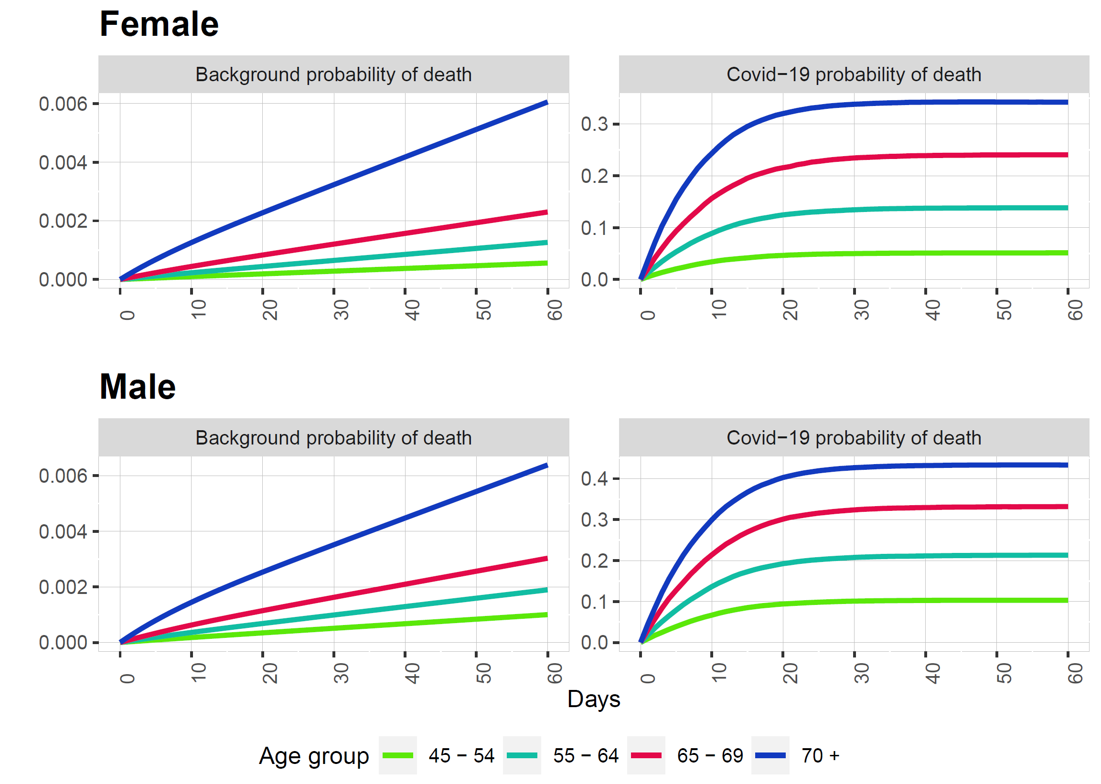

Figure 2:Background and COVID-19 specific probability of death by sex and age group.

The cumulative probability of death is minimal compared to the probability of death from Covid-19 in all age groups and both sexes. This should be reflected in a much higher death rate from Covid-19 on microsimulation. It can also be observed that the background probability of death is very similar in men and women. However, the probability of death from COVID-19 in men is higher in all age groups. The growth between groups is similar for both sexes.

Discount rates corresponded to inflation rates expected for Mexico for December and January and are obtained from the publications made by Mexico's central bank (cambia resto). Quality Adjusted Life Days loss by patient is acquired from a study of the impact of seasonal influenza in age groups “45 – 64 years old” and “65 + years old” 20 a very similar classification to the one used in this work. Influenza was chosen for being a disease that has similar manifestations to covid-19: respiratory disease; fever; chills; feeling tired, 20,21 although they differ in various aspects such as transmission, mortality and that COVID-19 appears to have higher impact on older age 21. Costs of hospitalization and treatments for patients with covid-19 in Mexico are obtained from several internet prices searches and press notes22–24. Due to the above it is recommended to take these estimates with caution.

Treatment effects are calculated incorporating the efficacy of each policy with the excess mortality additive model 25. First I computed risk reduction of covid-19 mortality percentage reduction with information with information from studies on the efficacy of remdesivir and dexamethasone in infected patients for 28 and 29 days17,26. In the case of dexamethasone, it only affects patients with assisted breathing17.

With this information and the population mortality rates, the following equations can be substituted and the treatment effects can be calculated.

Where is the proportion of treated patients surviving to day t and is the expected proportion of persons with certain age, sex and day characteristics without disease that survives to day t.25

Where is the proportion of not treated patients (placebo group) surviving to day t and is the expected proportion of persons with certain age, sex and day characteristics without disease that survives to day t. Reduction of Covid-19 mortality is:

Overall hazard:

**Obstáculos que anticipo**

El principal obstáculo que veo que puedo enfrentar tiene que ver con la recolección de datos en dos secciones. La primera es en la evidencia disponible de la efectividad de los tratamientos en la reducción de la mortalidad en pacientes con COVID-19. Esta es información que seguramente esté cambiando constantemente ya que todavía hay pocos ensayos clínicos de los posibles tratamientos y en la gran mayoría de los casos no es concluyente. La segunda sección son los datos de costos de servicios hospitalarios y medicamentos: En el caso de los servicios hospitalarios tengo estimaciones por notas periodísticas, pero me gustaría conseguir también otras fuentes de información, mientras que el precio de los tratamientos, a excepción de la dexametasona, no hay precios establecidos por que en muchos casos son nuevos, porque no han llegado al país o por la alta demanda. Otra área de oportunidad es hacer un análisis costo-efectividad mucho más completo y adecuado a los estándares internacionales, sin embargo, para comenzar esta etapa dependo de la recolección de datos.